My first WEBOTS project

Tutorial:
https://cyberbotics.com/doc/guide/tutorial-1-your-first-simulation-in-webots
https://cyberbotics.com/doc/guide/tutorial-2-modification-of-the-environment
https://cyberbotics.com/doc/guide/tutorial-3-appearance
https://cyberbotics.com/doc/guide/tutorial-4-more-about-controllers
(Nodes and API Functions)
https://cyberbotics.com/doc/reference/nodes-and-api-functions
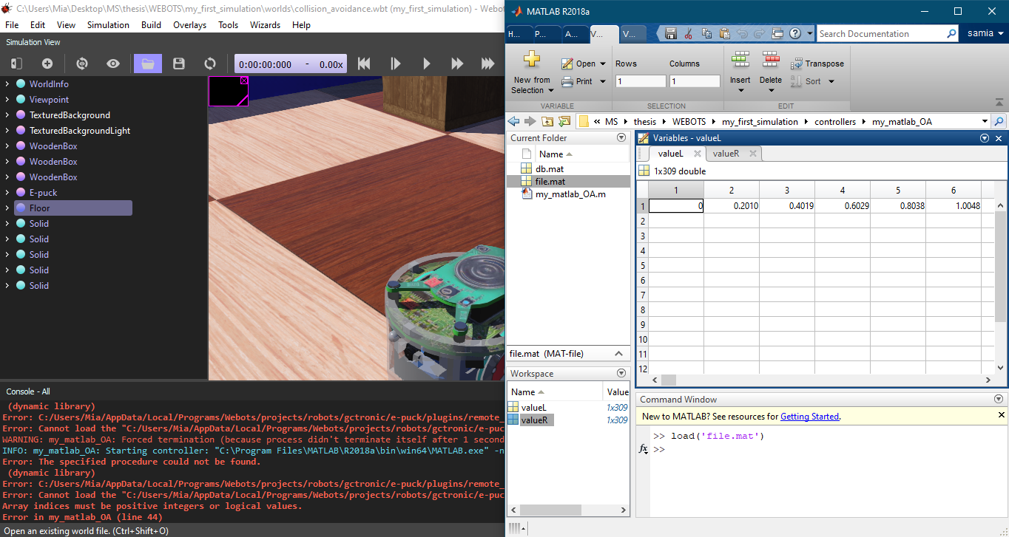
Is it possible to add force?
https://www.cyberbotics.com/doc/guide/programming#is-it-possible-to-apply-a-user-specified-force-to-a-robot

https://www.cyberbotics.com/doc/reference/supervisor?tab-language=c#wb_supervisor_node_add_force

